Answer 3
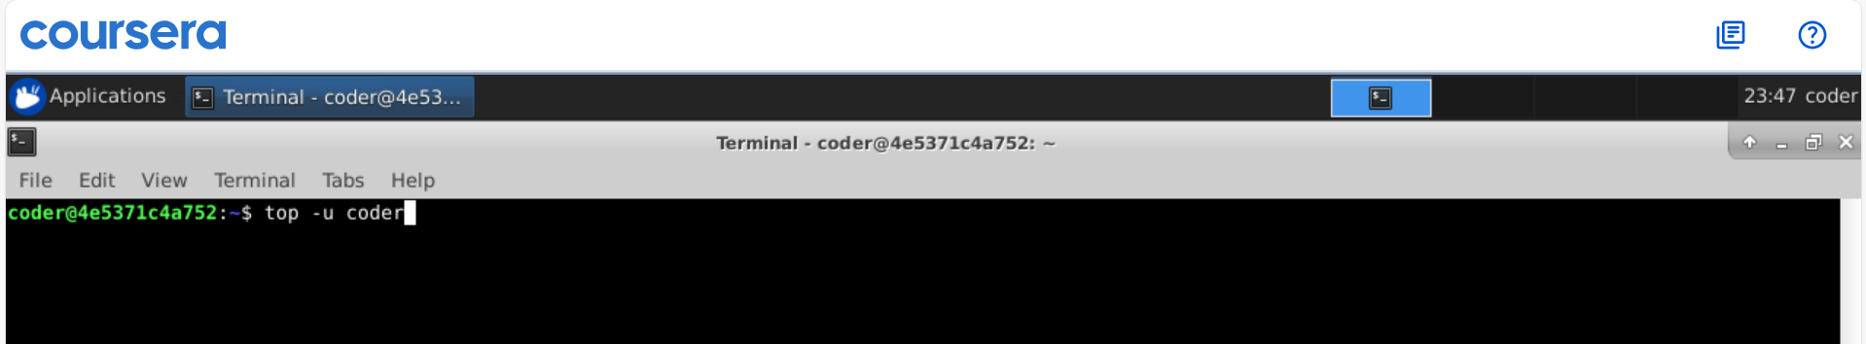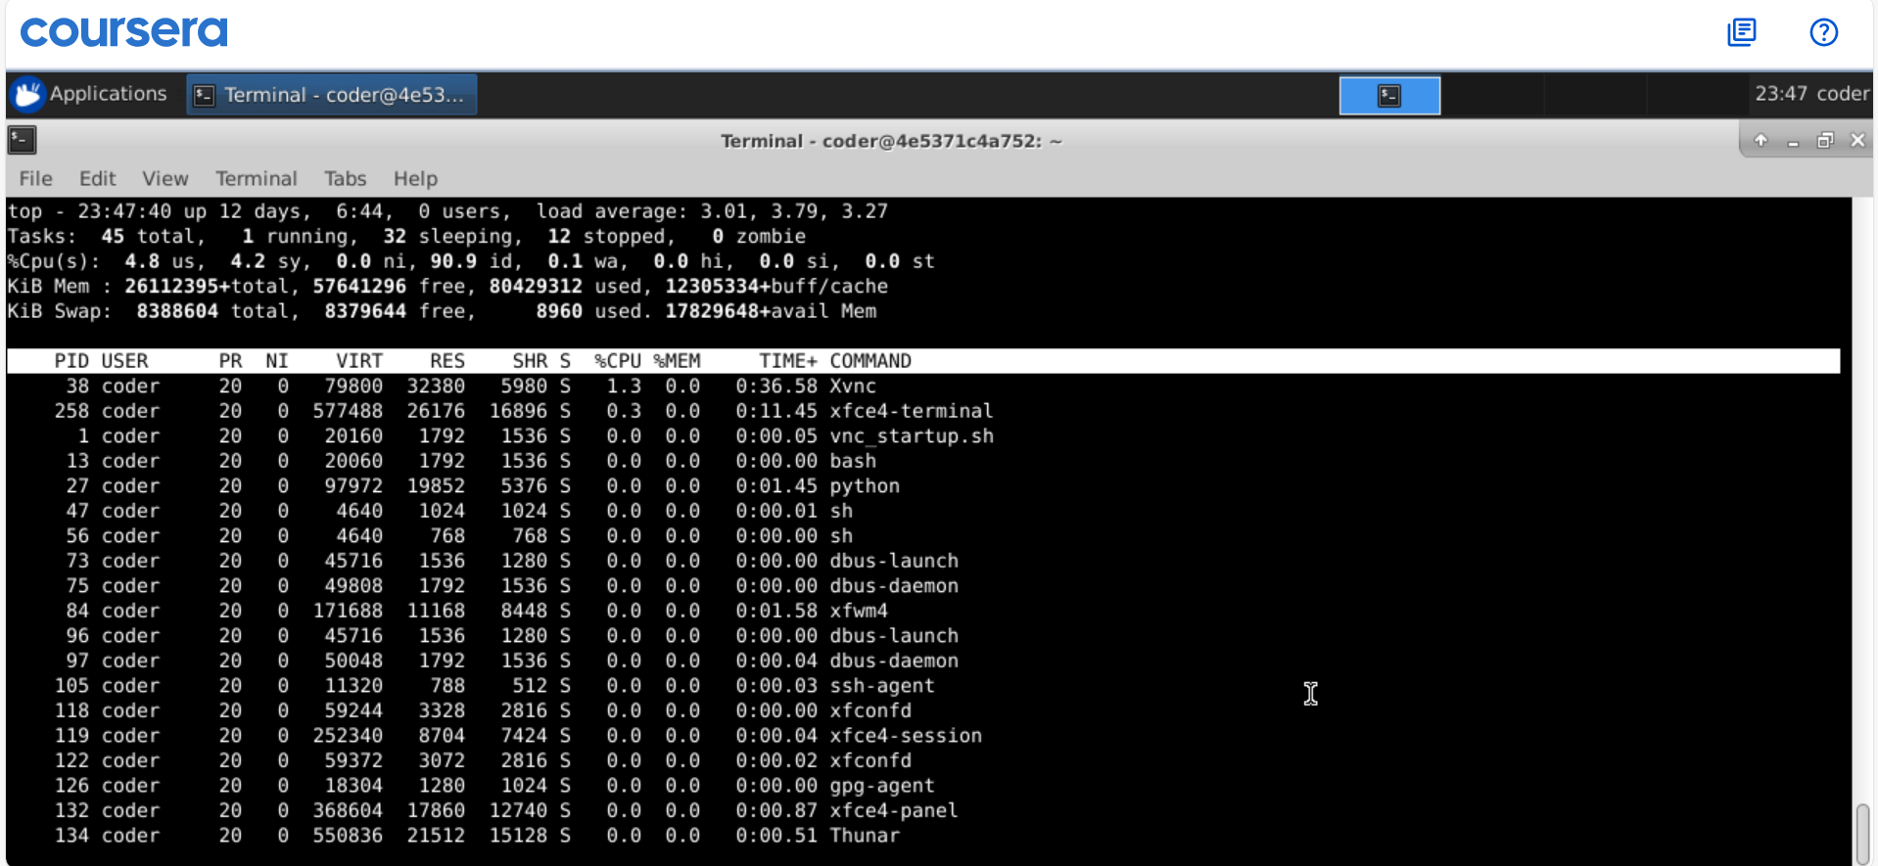
Explanation: Using top command will automatically show the CPU usage in highest to lowest. We can use -u option and specify the username to get the desired output.

